

**JOURNAL**

**SEMESTER : 1 - 2017/2018**

**COURSE CODE : MANB2113**

**COURSE : DATA VISUALIZATION AND INTERACTIVE DESIGN**

**PROGRAMME : MSc (BIA)**

**SUBMISSION DATE : 6 MAY 2018**

**PREPARED BY : 1. Ahmad Nizam Mohd Lazim (MAN171058)**

**2. Akmal Hayat Bin Jusoh (MAN171132)**

**3. Mohammad Nurihan Bin Salikin (MAN171032)**

**4. Mohd Mokhzaini Bin Mokhtar (MAN171142)**

**5. Muhammad Nidzam Maso'od (MAN171043)**

**6. Syed Hafizin Jamil Bin Syed Omar Sharifuddin (MAN171143)**

**SUBMITTED TO : DR DORIS WONG HOOI TEN**

Geospatial visualization application in water utilities planning and monitoring

|  |
| --- |
| Muhammad Nidzam Maso’od, Akmal Hayat Bin Jusoh, Mohammad Nurihan Bin Salikin, Mohd Mokhzaini Bin Mokhtar, Ahmad Nizam Mohd Lazim, Syed Hafizin Jamil Bin Syed Omar Sharifuddin  Advance Informatics School (UTM AIS) |

abstract

*Inefficient management and controls in water utilities such as water leakage, faulty water meters, and low water quality can be very costly. This paper proposes geospatial visualization in replacing the conventional methods of managing and monitoring the water network system and also explores a number of different application to overcome challenges associated with it. By using geospatial visualization or analysis such as GIS, Remote Sensing, Global Positioning System, and Internet of Things (IoT), problems related with water utilities will become well managed and more cost and time effective.*

*Keywords -* *Geospatial, visualization, water utilities, monitoring system, planning, application*.

1. Introduction

Water plays very vital parts in our everyday life. The absence of water will make even basic tasks such as drinking, cooking, washing dishes, and washing clothes to be a big problem.. Water is also very important for industries as without water, operation could be put on halt and can cause massive financial loss to the industry. In order to avoid any disruptions to the water supply, a good water utility planning and monitoring system is required.

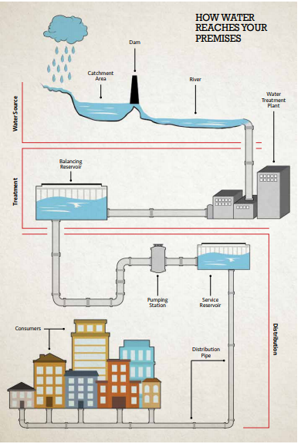

Figure 1 How water reaches your home

Water loss is a big issue for water utilities planning and monitoring system. The main cause of water loss is due to pipe leakage. For example, in 2015, in the state of Selangor Malaysia, on average, there are 211 leaked pipes and 14 burst pipes a day [1]. There are also issues caused by usage of old water meter causing inaccurate water usage readings. Another issue causing water losses is due to illegal water connection or water theft. In the year of 2015, the state of Selangor recorded 997 cases of water thief involving losses worth of RM2.1 million and equivalent to 6.4 million m3 of water [1]. Other than water loss, other important issues for water utilities planning and monitoring system are water quality.

From above arising issue on water utilities planning and monitoring system, we are focusing on the location of the event as we felt that is the most important factor in a quick response to minimize any impact. The question that we want to focus are

1. Where the leakage and pipe burst occur?
2. Where is the location of the faulty water meter?
3. Where is the location of illegal water connection or water theft?
4. Where is the location of degraded water quality issues occurred?

In this paper, we will study and review the application of geospatial visualization that can help us to resolve above question.

1. Existing works

Geospatial

What exactly is geospatial? Geo is associated from the word Earth as in geography or geochemistry while spatial is derived from the word ‘in space’ that is referring to anything which can be represented in terms of position, coordinates etc. [2] Nowadays, geospatial can be easily represented using Geographic Information System (GIS). Remote sensing technologies and Global Positioning System combined with computing power and software have enable us to progress in this technology. For example, in application such as WAZE or Google Map, enable us to track our current location, monitoring traffic jam, live personal tracking and lots more by using geospatial data and visualization.

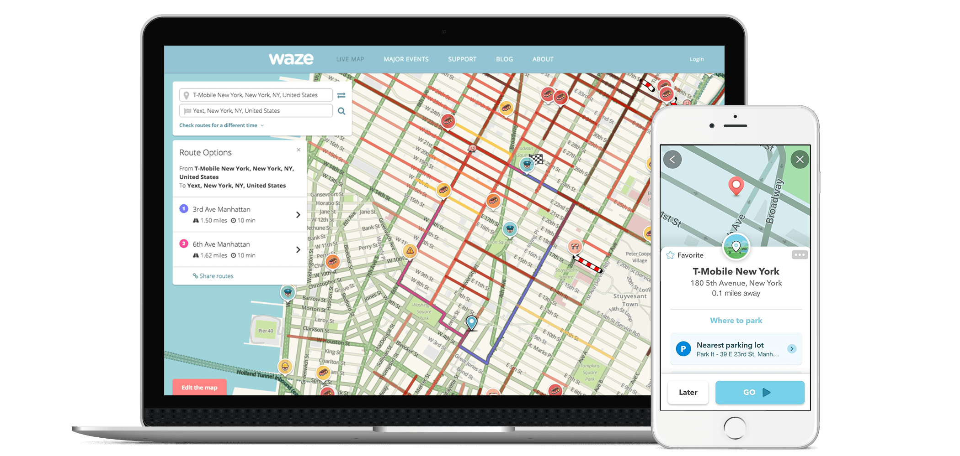

Figure 2 WAZE application using geospatial data

A research from [3] focuses on the software architecture of the system to implement a solution that is able to capture and analyze the data collected by the sensors, trigger alerts when anomalies are detected, and enable prediction of the contamination spread and its water source. Data collection will rely on new and currently existing sensors. The main steps involved in such scenario are listed below:

1. Monitoring and analysis of Supervisory Control and Data Acquisition (SCADA) data

2. Notify Event Management System(EMS) about event detection

3. Visualization of events

4. Start response workflow

5. Start simulation(s)

6. Display simulation results



Figure 3 The EMS presents events both in table form and as markers on a map

Visualization of detection event (Figure 3) is based on WebGenesis® [4] ,the Framework for generation of and support for Web-based Information systems. WebGenesis® is developed by Fraunhofer IOSB and provides several features to build information systems for knowledge management and decision support. Geospatial data, such as the water network layout, is obtained from the GIS server. The software selected to setup the GIS Server is GeoServer [5] , which provides an open source solution that implements OGC standards.

1. Findings

A web tool with a geospatial web front presenting a scalable, cloud-based has been presented in the study that develops Integrated Urban Water Model (IUWM) for forecasting urban water demand with options to assess effects of water conservation [6]. IUWM facilitates the development of water demand forecasts through automated retrieval of publicly available data for census, land cover and climate data inputs through a GIS interface. The required input data for creating an IUWM model are: service area boundary, computational subunit boundaries, land cover, imperviousness, population, households and daily climate (Figure 4). Users can upload the input data for the service area.



Figure 4 Schematic of the IUWM input data, area characteristics for projection of indoor demand, outdoor demand and stormwater

To prevent water leaking or pipe burst, S. Sharvelle, A. Dozier, M. Arabi and B. Reichel has published a research on the case study. Underground utility lines being struck by mechanized excavators during construction or maintenance operations is a long-standing problem. Besides the disruptions to public services, daily life, and commerce, utility strike accidents lead to injuries, fatalities, and property damages that cause significant financial loss. Utility strikes by excavation occur mainly because of the lack of an effective approach to synergize the geospatial utility locations and the movement of excavation equipment into a real-time, three-dimensional (3D) spatial context that is accessible to excavator operators [7].



Figure 5 Computational framework for knowledge-based excavation operations.

Computational details in geometric modelling of geospatial utility data for 3D visualization and proximity monitoring are developed to support knowledge-based excavation. A visualization framework named IDEAL that meets the outlined requirements is developed and presented in this paper to geometrically represent buried utility geospatial data and the movement of excavation equipment in a 3D emulated environment in real-time. The framework combined sensor-based tracking, georeferenced three-dimensional (3D) visualization, and real-time proximity emulation into a graphical emulation with three interconnected components, geometric modelling of geospatial data. real time excavator position and orientation tracking and excavator-utility proximity monitoring (Figure 4).

GIS technology combined with the hydraulic and water quality models, generally involved within a smart drinking water network solution, have been used in a new way for achieving a continuous and cost-effective monitoring of drinking water quality. More specially, the approach aims at improving the control management of the drinking water quality through networked and continuous water quality monitoring probes optimally located along the network considering physical as well as social and spatial criteria [8].



Figure 6 Santa Sofia aqueduct model scheme

This methodology has been applied to the real aqueduct Santa Sofia located in Campania (South Italy) and model has been built by collecting geometric, geomorphological and hydraulic data such as pipes depth, diameters, localization of valves and

related status, water variation of reservoir. These data have hence been performed into the HR-Info Waters software, obtaining the hydraulic model of the Santa Sofia aqueduct, characterized by 607 nodes, 1 reservoir, 5 valves, and 616 pipes (Figure 5).

Leaks in the pipeline can be wasteful in terms of resources and could also cause damage to the infrastructure if left unattended for a long period of time. To avoid this which may seem only a small problem, an efficient management system is necessary. One of the approach of detecting leaks in pipe networks using analysis by support vector machine [9]. How it works is by having the model train from a number of cases representing the pressure of leaks of various sizes and locations in the pipe network. However, to train this model, it would need a lot of cases to be used as training sets and by deliberately making actual leaks in the network is impractical. To overcome this problem, the training sets are obtained from a simulation tool. By using SVM method, a prediction of leaks can be made from the observation of pressure values in the pipe network.

Another method to detect leak in pipelines is through time-domain reflectometry. As traditional leak detection system are mostly based on acoustic techniques, which is susceptible to a few factors such as water pressure, pipe material, and environmental noise [10]. The traditional method also mostly do not provide a real time response which can be overcome by using a time-domain reflectometry (TDR)-based method to detect water leaks more efficiently. In this system, a sensing element (SE) which is a wire is buried together with the pipe during the time of installation is able to transmit information to identify any leaks along the pipe almost instantly. Leaks are detected through the readings of the dielectric characteristics of the soil and any significant changes in the normal readings would indicate a leak in the pipeline.

A study of a city in Uganda, where GIS data sets were obtained to define the spatial location of water meters in the city [11]. This is done by assigning block grids in order to map out all the meter locations as seen from (Figure 7).

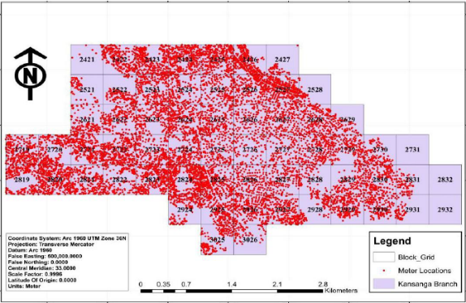

Figure 7 Meter locations based on blocks

All the data regarding meter performance was obtained from the utility database which have information on the date of metre installation, metre readings, and other relevant data. All of the data is compiled based on the reports on the functionality of individual meters on monthly basis. To detect a faulty meter, the probability of a meter failure is calculated based on factors which contributes to the meter failing such as meter age and components. After that, the range of probability is associated with a standard index called the Meter Failure Index which would be able to produce a heatmap to indicate which region or block is more likely to have a faulty or failing meter as shown on (Figure 8).

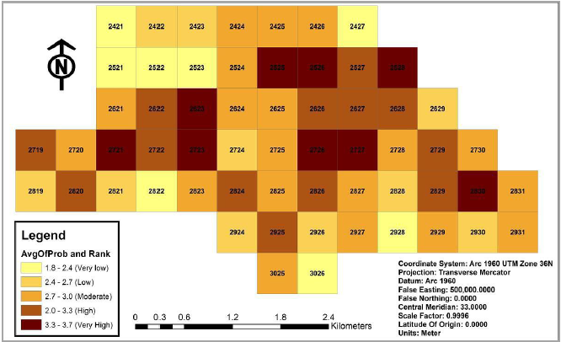

Figure 8 Heatmap indicating the probability of meter failure

1. Proposed Solution

what we want to propose

Based on the finding that we have gathered above, we believed there will always be a better solution to the problem. In this paper we are going propose a few methods or solutions in order to reduce or minimize the problems.

One of the proven solution on the water utilities planning and monitoring are by using specific *Geographic Information Systems* (GIS) Application. According to Wikipedia, *GIS is defined as a system designed to capture, store, manipulate, analyze, manage, and present spatial or geographic data* [11].

GIS Application basically able to leverage Geospatial collection of data and other technology such as Remote Sensing, Global Positioning System (GPS), and Internet of Things (IoT).

Basically, in case of the water utilities planning and monitoring, we are proposing the use of GIS Software, Geospatial Data, Remote Sensing data, and GPS Geotagging Data with IoT devices/sensors.

how does it works

1. data acquisition

Water piping basically cover wide geography area, for data collection or acquisition purposes, multiple factors and implementation methods will be utilized:

1. In the urban and sub-urban area which has wired or wireless internet infrastructure, multiples set of IoT devices/sensor will be attached to certain area of main water pipeline. Those devices what it does basically data acquisition based on the parameter setting for example water pressure and leaking sensing. Other than sensors data, IoT able to produce Geotagging data, basically location tag and route of the water pipeline. This will be very useful since GIS Application will be able to map out those data based on the GPS coordinates latitude and longitude
2. In other area which has no wired or wireless internet infrastructure, IoT devices/sensor will communicate through mobile operator using 3G, 3G+, or GPRS data line. [12]

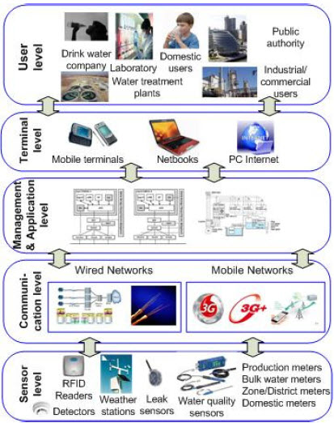

Figure 9 Illustration of How IoT works [12]

1. In the remote area which has no or limited internet coverage, remote sensing devices will be implemented. Remote sensing devices basically sending data using satellite communication.

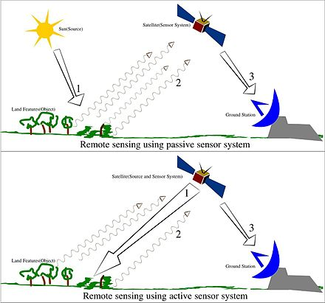

Figure 10 Illustration of how Remote Sensing works [13]

1. data storage, manipulation, and management

Collected data will be send back to data collection center through various communication channel for example wired and wireless internet, mobile network provider and satellite link provider.

Those data will be stored in raw database format. Next, Database administrator will make necessary process and changes to make sure data is clean before next data manipulation take place.

1. data visualization

Finally, from those cleaned data, GIS Application engineer or administrator would be able to manipulate further and make data analysis. The outcome of the analysis will be represented in visualization and dashboard reporting format. Some of the example of GIS visualization are illustrated below (Figure 11 & Figure 12): [14]

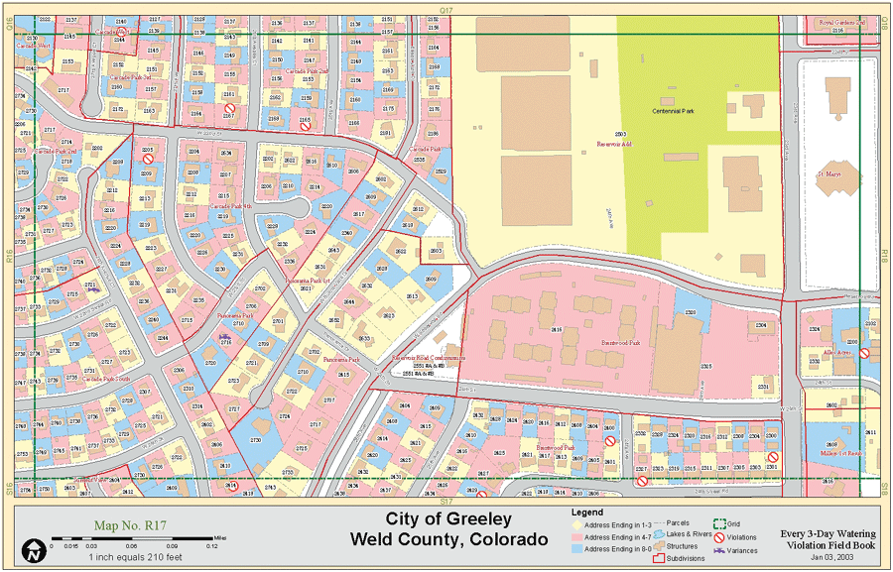

Figure 11 An example of a map book sheet that assisted city of Greeley staff in reporting water violations

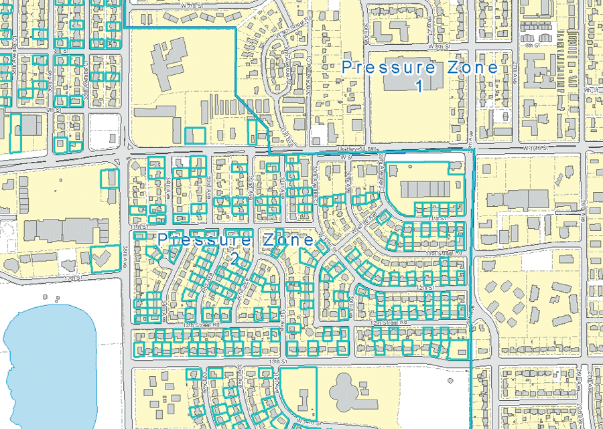

Figure 12 Selected location addresses water Pressure

1. Application

One of the proven solution on the water planning a monitoring utility is ESRI ArcGIS.

What is ArcGIS? It is basically commercial off-the-shelf solution built for geospatial visualization and practically can be used in more than 1000 application area [15]. One of the prominent area covered by the ArcGIS application is for water utilities management system. ArcGIS offers distinctive features for applying location-based analytics to GIS business practices. One of the key benefits is user will be able to gain greater insights using contextual tools to visualize and analyze GIS data. It also offers collaboration with other user by sharing insights via maps, apps, and reports [16].

ArcGIS application in assisting on the water utilities has proven in several cases. From the data analysis and visualization, ArcGIS would be able to assist water authority organization in the following area [17]:

1. Provide proven asset management which requiring trustworthy repositories to store, manage, and maintain detailed spatial and explanatory information about assets. For examples, Asset inventory; asset and maintenance cost tracking; analysis to support rate and cost of service studies; asset registry for asset value and depreciation; automated reporting of assets to support audits; property management
2. To make intelligent decision making brought about by redefining assets and operations information into applicable intelligence to refine both reactive and proactive services, elevate investments, and plan for capital projects. For examples, asset replacement forecasting, predictive asset planning, risk assessment analysis for high-consequence assets; damage assessment data collection;
3. Utility Business Planning. For examples, Mapping project areas; analyzing risk; leveraging asset scoring; integrating and analyzing of multiple spatial layers for decision making; sharing/collaborating with internal and external stakeholders
4. Product Quality and Operational Optimization. For examples, Water quality sampling, sample site planning and analysis; digital data collection and monitoring; real-time data sharing from field to office; water loss and repair management; valve exercising; water meter replacement tracking and analysis; water age analysis; real-time spatial monitoring; green infrastructure management; GIS layer integration across multiple departments; automated system integration through common locations; dashboards to track key indicators

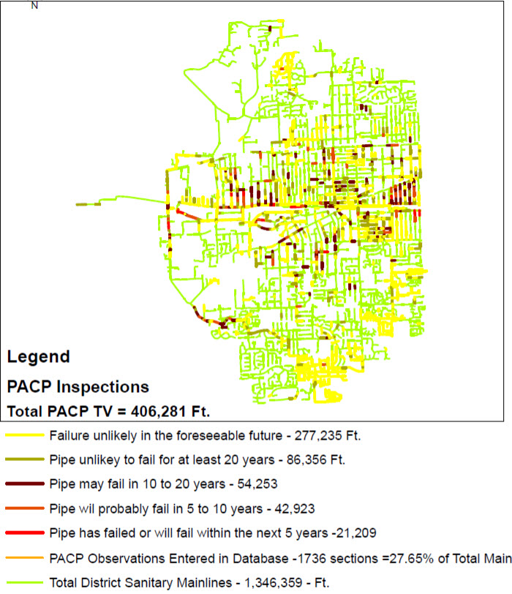

Figure 13 Visualization of water piping condition and analysis

1. Conclusion/ Future work

Recent technologies have come so far that helps mankind manage systems that may seem impossible or too much hassle to execute in the past. This paper has discussed on some of the technologies used in managing and monitoring water pipeline and how geospatial visualization or analysis has become a solution to many problems associated with it. From detecting leaks and pipe burst in the pipeline buried underground as well as potential water theft activity, it is now possible to pinpoint the location before excavation operations which is now more efficient and cost-saving. Also, the conditions of water meters can be mapped by utilizing existing geospatial visualization database to efficiently visualize by a map in order to take necessary actions should there be any faults to the meters or in need of replacement. Besides the management of the infrastructure related to the pipeline network, the water itself can also be monitored by using GIS technology to continuously monitor water quality in a cost-effective way. By using water quality monitoring probes, problems of contamination to the water directly can be reduced or avoided altogether.

All the problems that have been discussed can be solved by the use of technology such as the GIS software, geospatial data, and IoT. These technologies helps through the process from acquiring the data, to data storage, manipulation, management, which is then presented through data visualization. From here, all the necessary actions can be taken to manage the water system more efficiently and effectively.

References

|  |  |
| --- | --- |
| [1] | SYABAS, "“Performance Report For 2015.”," [Online]. Available: https://www.syabas.com.my/uploads/FINAL%20REPORT%20new.pd. |
| [2] | "Geospatial," [Online]. Available: https://www.ands.org.au/__data/assets/pdf_file/0004/974074/Geospatial.pdf. |
| [3] | E. Santamariaa, J. Moßgrabera, E. Brillb and I. M. Arangoc, "A system architecture for the detection and mitigation of CBRN," *Procedia Engineering ,* pp. 319-327, 2015. |
| [4] | F. IOSB, "WebGenesis Framework," May 2015. [Online]. Available: http://www.iosb.fraunhofer.de/servlet/is/21107/. [Accessed May 2018]. |
| [5] | "Open Source Geospatial Foundation," GeoServer, May 2015. [Online]. Available: http://geoserver.org/. [Accessed May 2018]. |
| [6] | S. Sharvelle, A. Dozier, M. Arabi and B. Reichel, "A geospatially-enabled web tool for urban water demand forecasting," *Environmental Modelling & Software ,* pp. 213-228, 2017. |
| [7] | S. Talmaki, V. R.Kamat and H. Cai, "Geometric modeling of geospatial data for visualization-assisted excavation," *Advanced Engineering Informatics 27,* p. 283–298, 2013. |
| [8] | A. Agresta, G. Fattoruso, B. Lanza, M. Fabbricino, M. Trifuoggi, S. D. Vito and G. D. Francia, "Applying numerical models and optimized sensor networks for drinking water quality control," *Procedia Engineering,* pp. 918-926, 2015. |
| [9] | D. D. S. D. M. a. S. B. John Mashford, "An approach to leak detection in pipe networks using analysis of monitored," *2009 Third International Conference on Network and System Security,* 2009. |
| [10] | E. D. B. G. C. G. L. L. D. G. C. D. Andrea Cataldo, "Enhancement of leak detection in pipelines through time-domain reflectometry/ground penetrating radar measurements," 2017. |
| [11] | "Geographic information system, Wikipedia," [Online]. Available: https://en.wikipedia.org/wiki/Geographic_information_system. [Accessed May 2018]. |
| [12] | C. T. V. G. Cristina Turcu, "An Internet of Things Oriented Approach for Water Utility Monitoring and Control," *Advances in Computer Science,* p. 180, 2012. |
| [13] | "Wikipedia - Remote Sensing," [Online]. Available: https://en.wikipedia.org/wiki/Remote_sensing. [Accessed 5 2018]. |
| [14] | "Sample of GIS Visualization," [Online]. Available: http://northlinegis.com/incline-management-studio/. [Accessed 5 2018]. |
| [15] | "1000 GIS Applications & Uses – How GIS Is Changing the World," [Online]. Available: https://gisgeography.com/gis-applications-uses/. [Accessed 5 2018]. |
| [16] | "ArcGIS Overview," [Online]. Available: https://www.esri.com/en-us/arcgis/about-arcgis/overview. [Accessed 5 2018]. |
| [17] | "GIS Supports Sustainable and," *An ESRI Whitepaper,* 2014. |
| [18] | V. Edmondsona, M. Cernya, M. Lima, B. Gledsona, S. Lockleyb and J. Woodwardc, "A smart sewer asset information model to enable an ‘Internet of Things’ for operational wastewater management," *Automation in Construction ,* pp. 193-205, 2018. |
| [19] | S. Brickera, V. Banksa, G. Galikb, D. Tapetea and R. Jonesb, "Accounting for groundwater in future city visions," *Land Use Policy,* pp. 618-630, 2017. |
| [20] | S. Christodoulou, A. Deligianni, P. Aslani and A. Agathokleous, "Risk-based asset management of water piping networks using neurofuzzy systems," *Computers, Environment and Urban Systems,* pp. 138-149, 2009. |
| [21] | L. Zhuhadar, E. Thrasher, S. Marklin and P. O. o. d. Pablos, "The next wave of innovationdReview of smart cities intelligent operation systems," *Computers in Human Behavior,* pp. 273-281, 2017. |
| [22] | S. Howell, Y. Rezgui and T. Beach, "Water utility decision support through the semantic web of things," *Environmental Modelling & Software,* pp. 94-114, 2018. |
| [23] | O. Sahin, R. Siems, R. Stewart and M. G. Porter, "Paradigm shift to enhanced water supply planning through augmented grids, scarcity pricing and adaptive factory water: A system dynamics approach," *Environmental Modelling & Software,* pp. 348-361, 2016. |
| [24] | J. Sirki€a, T. Laakso, S. Ahopelto, O. Ylijoki, J. Porras and R. Vahala, "Data utilization at finnish water and wastewater utilities: Current practices versus start of the art," *Utilities Policy,* pp. 69-75, 2017. |
| [25] | H. Hauser, "Integrating Spatial & Non-Spatial in Data Visualization". |
| [26] | G. A. ECHELAI, "Asset Management: Integrating GIS as a Decision Support Tool in Meter Management in National Water and Sewerage Corporation," 2016. |
| [27] | H. A. Gaikwad and P. V. Puranik, "AUTOMATED URBAN WATER SUPPLY SYSTEM AND THEFT," *International Journal of Electronics and Communication,* Jun 2015. |